Blink Without Delay

Sometimes you need to do two things at once. For example you might want to blink an LED while reading a button press. In this case, you can't use delay(), because Arduino pauses your program during the delay(). If the button is pressed while Arduino is paused waiting for the delay() to pass, your program will miss the button press.

This sketch demonstrates how to blink an LED without using delay(). It turns the LED on and then makes note of the time. Then, each time through loop(), it checks to see if the desired blink time has passed. If it has, it toggles the LED on or off and makes note of the new time. In this way the LED blinks continuously while the sketch execution never lags on a single instruction.

Hardware Required

* Arduino or Genuino Board
* LED
* 220 ohm resistor

Circuit

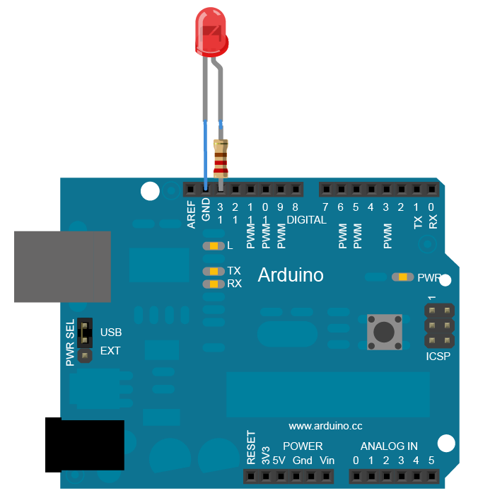

To build the circuit, connect one end of the resistor to pin 13 of the board. Connect the long leg of the LED (the positive leg, called the anode) to the other end of the resistor. Connect the short leg of the LED (the negative leg, called the cathode) to the board GND, as shown in the diagram above and the schematic below.

Most Arduino and Genuino boards already have an LED attached to pin 13 on the board itself. If you run this example with no hardware attached, you should see that LED blink.

Schematic

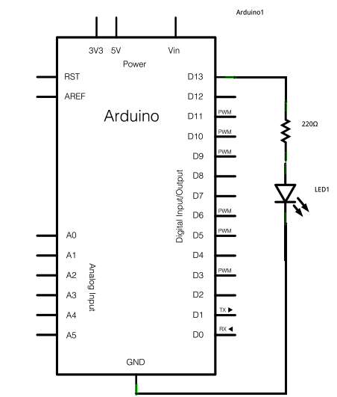

After you build the circuit plug your board into your computer, start the Arduino Software (IDE), and enter the code below.

Code

The code below uses the [millis()](https://www.arduino.cc/en/Reference/Millis) function, a command that returns the number of milliseconds since the board started running its current sketch, to blink an LED.

*// constants won't change. Used here to set a pin number:*  
const int ledPin =  LED_BUILTIN;*// the number of the LED pin*  
  
*// Variables will change:*  
int ledState = LOW;             *// ledState used to set the LED*  
  
*// Generally, you should use "unsigned long" for variables that hold time*  
*// The value will quickly become too large for an int to store*  
unsigned long previousMillis = 0;        *// will store last time LED was updated*  
  
*// constants won't change:*  
const long interval = 1000;           *// interval at which to blink (milliseconds)*  
  
void **setup**() {  
  *// set the digital pin as output:*  
  pinMode(ledPin, OUTPUT);  
}  
  
void **loop**() {  
  *// here is where you'd put code that needs to be running all the time.*  
  
  *// check to see if it's time to blink the LED; that is, if the difference*  
  *// between the current time and last time you blinked the LED is bigger than*  
  *// the interval at which you want to blink the LED.*  
  unsigned long currentMillis = millis();  
  
  if (currentMillis - previousMillis >= interval) {  
    *// save the last time you blinked the LED*  
    previousMillis = currentMillis;  
  
    *// if the LED is off turn it on and vice-versa:*  
    if (ledState == LOW) {  
      ledState = HIGH;  
    } else {  
      ledState = LOW;  
    }  
  
    *// set the LED with the ledState of the variable:*  
    digitalWrite(ledPin, ledState);  
  }  
}

============================

const int ledPin = LED_BUILTIN;

int ledState = LOW;

unsigned long previousMillis = 0;

const long interval = 1000;

void setup() {pinMode(ledPin, OUTPUT);}

void loop() {

unsigned long currentMillis = millis();

if (currentMillis - previousMillis >= interval) {

previousMillis = currentMillis;

if (ledState == LOW) {

ledState = HIGH;

} else {

ledState = LOW;

}

digitalWrite(ledPin, ledState);

}

}